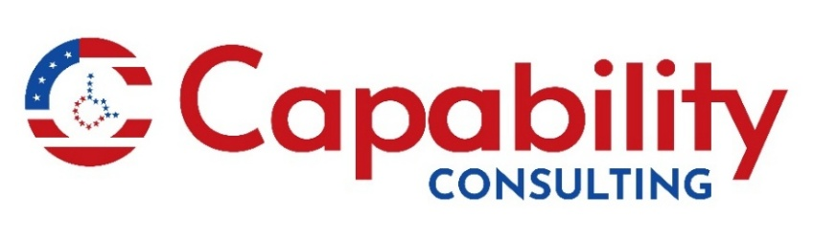
Say This, Not That

Words matter. They can build up people or minimize them.

Always use language that reflects our American belief that everyone is equal and fully a part of our society, regardless of level of ability. This helps to ensure respect from fellow citizens, and especially from the media, which often reflects our society’s perceptions.

The Disabled - Use “people first” language when referring to individuals with disabilities. Put the focus on the person, not the disability, i.e., people with disabilities.

Able-bodied – people with intellectual or developmental disabilities could be able-bodied, but they still have a disability. Focus on their ability to produce and contribute by saying work capable.

Suffers from - Connotes physical/emotional pain. Instead, say the person has (name of disability).

Afflicted or affliction - Person who has or is affected by is much better.

Victim – Having a disability is not a crime in and of itself, even if it resulted from a criminal act.

Confined to a wheelchair or wheelchair-bound – Is the person tethered to their chair with ropes? No. It is better to say the person uses a wheelchair.

Crippled, crippled, or any form of this word - Usage in our language has made this the equivalent of labeling someone as being damaged or rendered useless. It is far better to say the individual has a disability, and if necessary, describe specifically how the disability affects the person.

“The blind kid,” or similar qualifiers – The term “blind” is okay to describe the condition, but not a person. Please use person who is blind when referring to people.

Disease, defect, or deformity - A disease may cause a disability, but the person affected by it may be perfectly healthy. Nobody appreciates being described as diseased, defective, or deformed. Unless there is a specific medical diagnosis, speak of condition(s).

Special Needs- this sets disabled people apart from their peers in an unflattering that evokes pity rather than compassionate understanding. Use of this term can cause unwanted bias that results in exclusion and isolation. Disabled children and adults share the same needs as those without disabilities. They need to feel safe and have a sense of belonging in any environment. The needs may present a little differently or need greater attention, but they are the same.

Drain or burden - No one wants to be referred to as a drain or burden on loved ones or society. Instead, acknowledge and appreciate family and caregivers’ added responsibilities.

Handicap/The Handicapped – These terms come from a time when people with disabilities resorted to begging on the street with “cap in hand" because they could not find gainful employment that enhanced their dignity. Instead, refer either to the specific disability, or simply say the person has a disability.

Physically/Mentally challenged - People with disabilities face multiple challenges, but that is not the point. Most people with disabilities are perfectly aware of their differences and challenges. Using a euphemism will not change that for them or the people around them.

Retard or retarded - Use of these words in any context is quite offensive and inappropriate. It is acceptable to say a person has an intellectual disability or a developmental disability. Acceptable Shorthand: IDD

Spastic - A diagnostic qualifier in specific medical contexts, conversational use is unacceptable.

Autistic – Speak in terms of someone having autism or being autistic. “Sharon has autism” “She is autistic.”

Pro Tip: People, disabled or not, are individuals with their own name. Addressing them by name conveys awareness of their individual dignity and worth.

For more information contact Melissa Ortiz, melissa@capabilityconsulting.org

